NYSACOP Sponsored Training Seminar
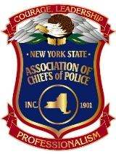
“Media Basics for Police Chiefs”

Course Description: The ability to effectively communicate with the media in the current social and political environment has become one of the most important aspects of the job of a police leader. This course is an introduction to media relations as it pertains to social media as well as television media. Together we will explore the “do’s and don'ts” for police executives irrespective if they have a dedicated Public Information Officer (PIO) or if they handle media relations themselves. Part of the course will include the examination of real-world examples in media relations and lessons learned that will assist police executives to be successful in this very important part of their job.

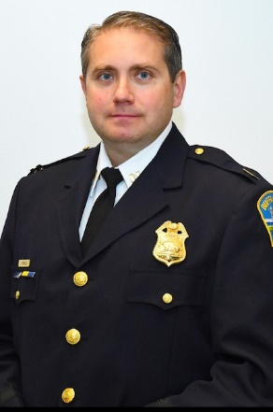
Captain Rinaldo

Instructor Bio: Captain Jeff Rinaldo is a 23-year veteran of the Buffalo Police Department. He is also a graduate of Canisius College with a Bachelor of Arts degree in Sociology. Over the course of his 23-year career, he has worked as a patrol officer, a Community Police Officer, a Detective in the Sex Offense Squad also investigating juvenile crimes and elder abuse, Patrol Lieutenant, Lieutenant in charge of special projects where he supervised social media platforms, the department body camera and Taser implementation programs, and assisted in the implementation of the BPD Emergency Response Team. Captain Rinaldo was promoted to his current rank in 2017 and became the department Chief of Staff where he oversees all media relations, the department Body Camera Program, citywide camera surveillance system, discovery unit, FOIL unit, management information systems, Commander of the Hostage Negotiations team and other important projects. In his 3 years as the department Public Information Officer, Captain Rinaldo has established himself as an effective and respected PIO handling numerous in custody deaths, the on-duty death of an officer, officer misconduct cases, and many New York State Attorney General investigations.

