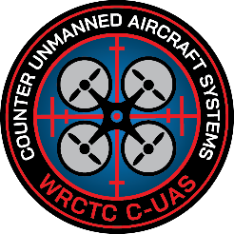
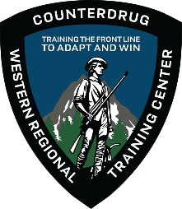
WESTERN REGIONAL
COUNTERDRUG TRAINING CENTER

COUNTER UNMANNED AIRCRAFT SYSTEMS (CUAS) FUNDAMENTALS TRAINING
Learn what you need to know about countering the drone threat!

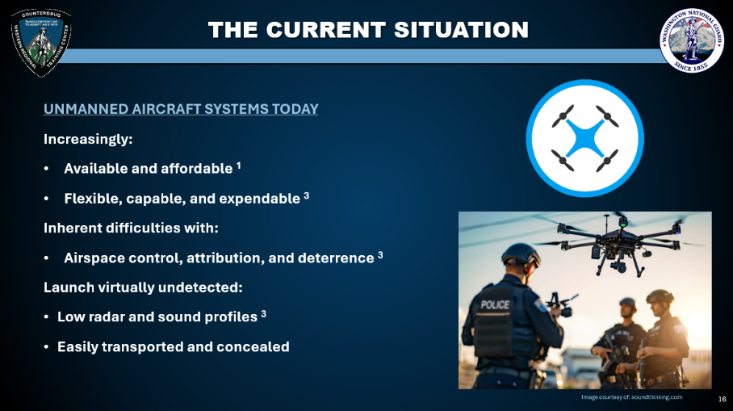
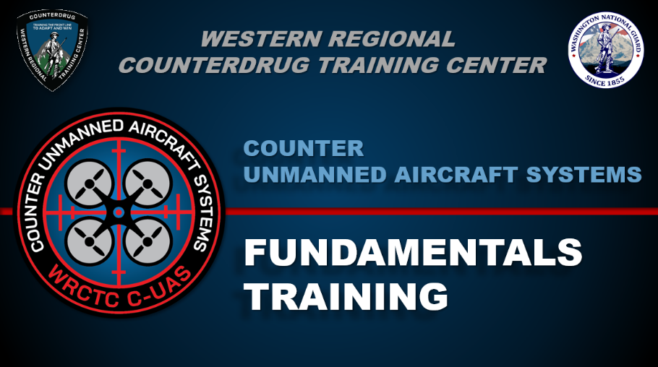

Who: All Interested Public Safety Partners
What: WRCTC Counter-UAS Fundamentals Training
Where: Bisgrove Hall Room 350, 5795 Lewiston Rd, Niagara University, NY 14109
When: August 26th, 2026. 8:00am - 4:00pm
Register now with the link below or QR code to the left!
https://www.wrctc.org/event/?eid=f6405954-38d4-4db7-85ff-dcf21ad7a20e
The WRCTC is now offering a FREE one-day, eight-hour course introducing the fundamentals of countering UAS. Topics covered during the course include:
- Fundamentals of UAS technology
- UAS types and capabilities
- Laws and regulations for drone operations
- U.S. Army Counter UAS principles
- Fundamentals of CUAS technology and processing

